Topic 4. Electronic budget

Electronic budget is a unified system for managing state and municipal (public) finances of the Republic of Kazakhstan using information and telecommunication technologies.
The electronic budget system is an integral part of the electronic model of public administration and is subject to the general principles and main directions of the implementation of the policy of informatization in the field of public administration.
The concept for the creation and development of an integrated information system for public finance management " Electronic budget " provides for the following areas :
- creation and implementation of a unified system of forms used in the formation of information in electronic form about the activities of public law entities in the field of public finance management;
- transition to legally significant electronic document flow in the field of public finance management;
- automation of accounting activities , as well as integration and interconnection of all types of accounting and reporting of public legal entities;
- integration of public finance management processes in public law entities;
- ensuring the interconnection of information on the financial indicators of public law entities with indicators of the effectiveness of their activities;
- ensuring transparency and publicity of information on the activities of public law entities in the field of public finance management.
The functional capabilities of the "Electronic Budget" system will allow the use of portal solutions, a system of forms, registers and classifiers that are uniform for all users, which in turn will create conditions for centralized accounting in electronic form within the framework of public law education (formation of a single general ledger).
Based on the transition to electronic registration, accounting and control of execution of documents, it will be possible to automatically generate management documents and regulatory reporting and provide them to various categories of users in accordance with regulated access to reporting and primary documents. Using distributed access capabilities will allow users to work with reporting in an interactive mode, including using mobile devices.
All government bodies and government agencies must become users of the " Electronic Budget " system. In addition, the " Electronic Budget " system will be provided on a gratuitous application basis to all state authorities of the constituent entities of the Republic of Kazakhstan, local governments, organizations of the public administration sector, including according to the " software as a service " model . Each user (regardless of his territorial remoteness) will be provided with interactive access to information resources, including from mobile devices.
When designing and developing the " Electronic Budget " system, the following principles of creating a technical architecture are observed :
- centralized or cloud technologies for storing and processing information;
- use of an integrated telecommunication data transmission medium;
- creation of standard interfaces for interaction of information resources with other (external) systems within the framework of the "Electronic Budget" system, based on open industrial standards of intersystem interaction;
- ensuring the readiness of the technical infrastructure for development in terms of expanding functionality, increasing the number of users and serviced organizations, improving the quality of services provided;
- unification of interfaces to ensure all types of interaction with the system and its components on the basis of uniform unified rules;
- ensuring the required level of fault tolerance and disaster recovery.
The full-scale implementation of the Electronic Budget system is planned to be completed by 2015.
The implementation of the main directions for the creation and development of the " Electronic Budget " system will contribute to the coordination of the activities of public authorities, the achievement of harmonization and simplification of management and accounting operations, an increase in the efficiency and transparency (openness) of the activities of organizations in the public administration sector.

The Open Budgets portal ( budget.egov.kz ) is a component of the Open Government project, created to ensure transparent budgeting and the development of public control over the expenditure of budget funds.
According to the Law " On Access to Information " on the portal, state bodies and institutions of the legislative, executive and judicial branches of government, local government and self-government post budget statements, consolidated financial statements, the results of state audit and financial control, as well as public discussion of draft budget programs and reports on their implementation.
Any citizen of the Republic of Kazakhstan interested in budget spending can leave comments, remarks and suggestions.
Working with the portal
The main page shows in a schematic form the stages of planning, approval and execution of the process of forming the budget of the central state bodies and local executive bodies, as well as statistics on the information posted and infographics on income, expenses, credit and deficit of the Republic of Kazakhstan. For the convenience of users, there are also descriptions of definitions and terms found on the portal.
In order to get acquainted with the information on the implementation of budget programs, you must click on the "Budget programs" tab and select the appropriate subsection: " Project ", " Approved programs " or " Implementation reports ".
A list of all available documents of the selected category will appear in the window that opens, which can be filtered by central state and local executive bodies.
By going to the page of the budget program you are interested in, you will familiarize yourself with its full description, each item of which is available for commenting. Also, here you can download the original document in Excel format.
For commenting, authorization is required, which in turn requires registration on the eGov.kz electronic government portal. The details of this procedure are described in the " For the first time on the portal " section of the e-government portal.
The section " Materials " contains data on consolidated financial statements, budgetary statements of government agencies, and information on the results of government audit and financial control.
Consolidated financial statements, in turn, consist of the following documents:
- Consolidated balance sheet;
- Consolidated statement of financial results;
- Consolidated cash flow statement (direct method);
- Consolidated statement of changes in net assets / equity;
- Explanatory note to the consolidated financial statements.
Budget reporting includes:
- Reports on the execution of local budgets;
- Reports on the execution of the republican budget;
- State budget execution reports;
- Consolidated budget execution reports;
- Reports on the execution of regional budgets;
- Reports on the implementation of budget programs;
- Strategic plan implementation reports;
- Reports on receipts and use of the National Fund of the Republic of Kazakhstan.
The report page displays the budget type, the name of the financial institution, the date of approval and relevance, the report itself, and a link to download documents.
The " Archive " section contains all projects, approved programs and reports on the implementation of budget programs, on which public discussions have already taken place.

The budget of Kazakhstan should be open and transparent. Exactly at the moment when state bodies begin to publicly discuss what to spend, and then also transparently spend taxpayers' money, then the country's main financial document will become balanced, and citizens will see that the authorities are actually doing something. It is worth noting that a platform appeared in Kazakhstan last week, where qualified experts, deputies of the Mazhilis, employees of the counting committee and all interested persons can obtain information on the state of public finances at the macro level. To this end, the TALAP Center for Applied Research developed the OpenBudget.kz portal, which was presented during the TALAP.Talks online round table. New portal For almost two years, work has been carried out on the study of world leaders in the field of the open budget index, and the launch of the portal itself. Openbudget.kz should become a new platform where all the main indicators of budget statistics will be visible: the republican budget itself, tax revenues, public debt for the current situation, National Fund assets, expenditures, deficits, transfers, and so on. Everything will be updated in real time. As well as budget parameters by year.
“For analysts, journalists, deputies and everyone who is interested, we have made more detailed links in each direction. These are the consolidated budget, the state budget, the republican budget, the local budget, the state debt, the National Fund. All these statistics are there, represented by various graphs. We studied a lot of analytical materials, how this budget is presented, so that everything was clear to ordinary citizens, ”says Askar Kysykov, an analyst at the TALAP Center for Analytical Research .
On the portal you can find all the information where, why and for what each ministry and department spends money for each budget program. And in dynamics.
"It is very important. Because now all this information is in various documents, in various laws, in execution reports. We tried to collect it all into a single database, ”explains Kysykov.
For unprepared users, the site has made a kind of training manual: what the budget consists of, types, levels of budgets, including the National Fund, and so on with explanations. And there is also a budget calendar.
“Having entered it, you can see at what stage what budgetary processes are currently taking place. We can see from the calendar that changes to the 2020 budget have already been adopted. The first refinement has passed. Now we are awaiting the report of the counting committee. And a new forecast of socio-economic development for already 2021-2026 is being formed, ”the analyst adds.
For convenience, the site contains in one list all the documents that relate to the planning of budgetary processes and budget execution. And, of course, analytics.
“Analytics are our TALAP author's articles with explanations. Our main product is an assessment of fiscal sustainability in an environment of low oil prices ... We carried out assessments, and it turned out that at current oil prices, $ 20-30, if they persist, the fiscal system is highly sustainable. And even according to the most conservative estimates, the funds of the National Fund will be enough for us for six years. Accordingly, there is a margin of safety, and it is large, ”Kysykov quoted one of the studies.
There is no link between budget and results
The coronavirus pandemic has exposed the most serious budgeting problems in Kazakhstan. It is today that inconsistencies, the lack of connection between the allocated funds and the results, have become clearly visible. This was stated by the director of the Sange Research Center Zhanar Dzhandosova. It is this organization that has been calculating the budget openness index since 2006.
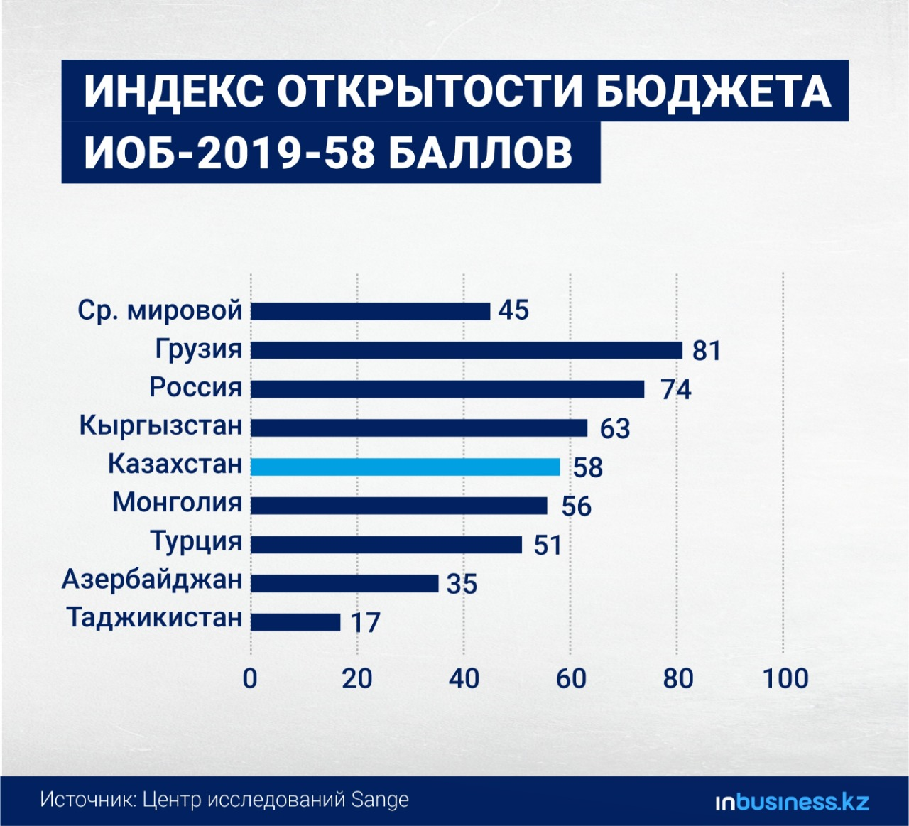

“We are constantly raising the issue of the national fund. That we have some vulnerable groups. There is a small business, various market actors who need or do not need help. And now this pandemic has exposed exactly the questions about who needs this help, whether the funds of the National Fund will be enough for us. And now the interest in budget transparency has grown several times. These are some positive things that such a critical situation brought with it, ”says Dzhandosova.
According to her, today Kazakhstan is in 58th place in the index of budget openness due to limited information. It's about in the middle of the list. Mongolia, Azerbaijan and the countries of Eastern Europe are on the same level with us.
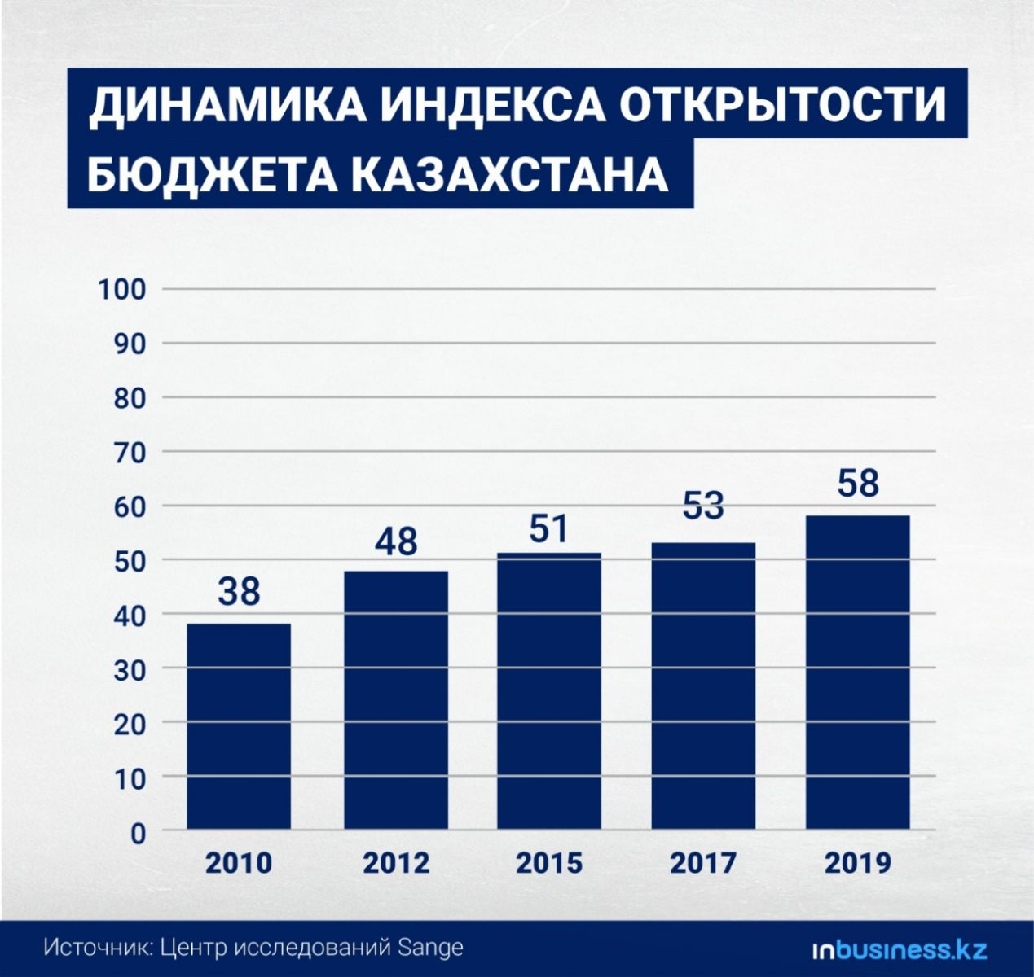
“Unfortunately, for some time now we have not been able to go beyond this figure of 60 ... Since 2010, it turns out that in 10 years we have improved our performance by 20 points. But during this time, Kyrgyzstan improved by 55 points, Georgia - by 47, and Russia - by 27 points. That is, we are moving consistently, steadily, but slowly, ”stated the head of the research center.
Oddly enough, but "pulls back" or planning and completeness of information suffer from the absence of only one document - the draft budget, which, in theory, should be presented to parliament in late August - early September. And by the end of the year, it will be discussed by the deputies together with the civil society.
“What are the main problems? We do not have an economic classification - this is the thing where we look at salaries, at capital expenditures. But we do not have it in the draft budget. We have no connection between politics and finance. We do not say why we suddenly decided to finance this or that. This is stated in the program documents, but specifically in the budget, when the figures are already being signed, these things are not there, ”says Dzhandosova.
There are also problems in terms of macroeconomic forecasts given by the Ministry of National Economy. There are simply no independent research institutes in the country that could check - are the calculations correct? Low scores on the budget index in Kazakhstan and due to the lack of public organizations in the discussion of budget formation.
"Although the parliament says all the time:" We go to the regions, we collect their orders from them. " But in fact, there is virtually no evidence that these hearings will ultimately affect the budget, ”she explains. The public's point of view on budget issues should also be mandatory. It is necessary to hold committees, public hearings on the macroeconomic and financial foundations of the budget. But this is not being done and "maybe it does not even occur to me."
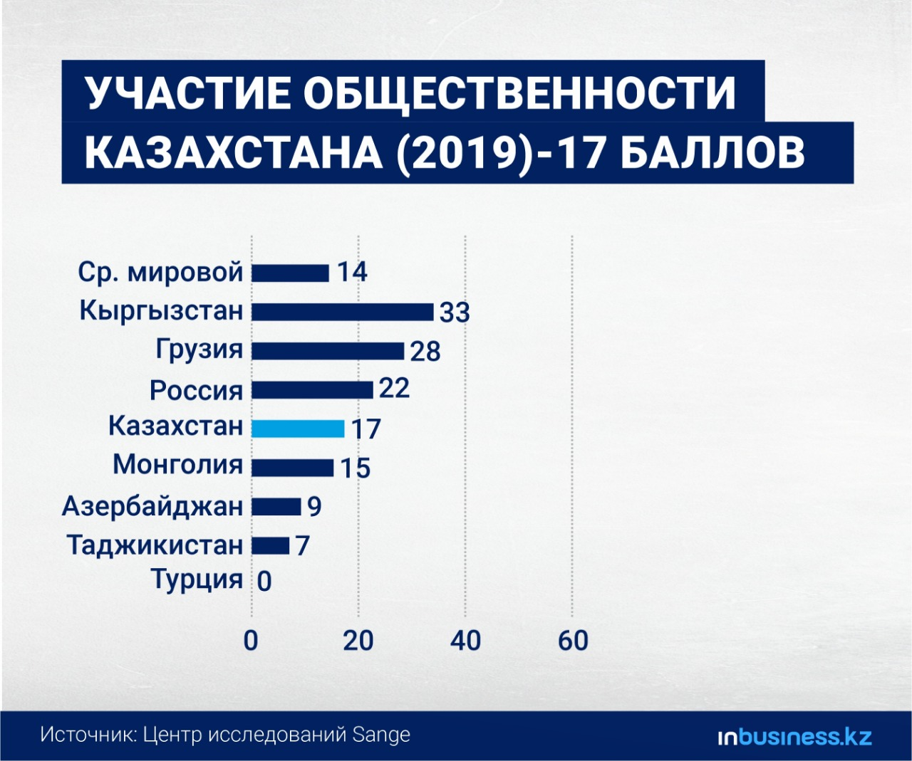
“There should be public hearings of the committees for individual administrative units with their reports. The public should even be invited to the republican budget commission, so that projects such as the LRT or the recent decision to build this very expensive hospital for some billions (infectious diseases hospitals in Nur-Sultan and Almaty. - Approx.), So that the public also participates ( and spoke about expediency or inexpediency. - Approx.). It is imperative to create mechanisms for public involvement. Especially at the planning stage. To listen to the public, the beneficiaries, those to whom these roads are laid, to whom the water lines are laid. Conduct surveys, conduct consultations, ”concluded the director of the research center. A budget is like an aquarium with fish A transparent budget is profitable, says Sholpan Aytenova , head of the public fund Zertteu Research Institute . Moreover, it is beneficial both from the technical and political sides. After all, transparency not only improves ratings, but it also improves and enhances the efficiency of public finance management. The simplest example of the advisability of a transparent budget is like a fish tank.
“Why should an aquarium be transparent? To see how many fish survived there, how many died, to plan food. When I heard this at the online lesson of my second-grader son, I realized that this is the simplest and most understandable explanation of expediency, ”said Aytenova during the online round table TALAP.Talks.
It is expediency that, according to her, helps to understand whether certain expenses are needed or not.
“Every day, we publish information in an understandable and accessible form, which purchases were made to fight the coronavirus during the state of emergency. And there was one of the purchases - a company specializing in the sale of flowers won a tender for the supply of medical masks. We published it, and two days later , the anti -corruption department in the Turkestan region contacted us and said: “Thank you for noticing this. We declared this deal invalid for a number of reasons. Including because it is not a specialized company in the supply of medical products. " As a result, they monitored the public procurement website and saved 221 million tenge to the budget in their area, ”the head of the public fund cited an example.
The second and most important factor, she said, is trust. Because in times of emergency, it is transparency that helps overcome fear and mistrust. And only open information makes people confident that the state is capable of doing something and protecting its citizens. Another aspect that an open budget provides is an increase in the efficiency of public administration. However, the position of the Ministry of Finance, in her opinion, should be not only to say “we are transparent” and to voice our place in the international rating, but “to reduce transaction costs”. Today, Aytenova says, it is necessary to create a separate website for the use of the funds of the National Fund, and not be limited to one file "Aggregated Report on the Use of the National Fund's funds," which gives out how many taxes were received, what was the investment income. In addition, the transparency of the quasi-public sector is needed, so it is time to start publishing their financial statements “in machine-readable form”.
“7000 organizations in the quasi-public sector file their financial statements in a PDF file. This represents a very large burden and a very large amount of work for the controlling government agencies in order to check which of these government agencies are profitable, which are not profitable, and which should be closed. If all these reports were in machine-readable form, it would be very easy to process them and already see all the results. As for the audit commissions, as for the counting committee, and for the internal state control itself, ”explains Aytenova.
There is a lack of transparency, in her opinion, in terms of public participation in the early stages of budget planning. Indeed, at the central level, the text of the document is published only after it has been formed and entered the parliament. Local budgets are not available at all.
“This practice needs to be changed. Then we will have an increase in the part of the index, which deals with public participation, ”she is sure.
The next point is that the Ministry of Finance is a technical body that collects budget data, summarizes them and is already preparing the draft document itself for parliament. But the sectoral government agencies themselves should be responsible for the budget process internally, Aytenova believes, respectively, the budget projects should be discussed at the planning stage by each government agency separately.
“Transparency is not a panacea. Openness should lead to development and discussion. But for this to happen, this openness must be understandable and accessible. And these aggregated types of reports - our incomes are such, expenses are such - they do not say anything to ordinary citizens. All these separate projects, which were done by separate organizations, due to open budgets, they are not viable. And institutional viability can only be provided by such a portal as Open Budgets, she summed up.
The Ministry of Finance agrees and is ready for dialogue
The Ministry of Finance assures that they plan to increase the efficiency of budget planning. And in general, to optimize this process. Primarily due to optimization and digitalization. Since, explains the Vice Minister of Finance Ruslan Ensebayev, because of the "paper Talmuds", it is difficult to include the public in the discussion. Within a year, they intend to create a full-fledged system for digital budget planning. Another challenge is database integration. With the Ministry of Labor and Social Protection of the Population - for pensions and benefits, with the Ministry of National Economy - for investment and PPP projects, and so on.
“This year, we are working with the Ministry of Economy to develop a strategic planning module to link the strategic goals with the budgets allocated to achieve these goals. What effects are planned? A 30% reduction in all supporting documents, a 70% reduction in costs associated with paper planning: stationery, travel. Previously, with the Talmuds of documents, it was necessary to come here, to the center, this is also very ineffective. In general, it is planned to reduce at least two times the process of coordinating budget applications with their administrators of budget programs and with the authorized body, with the Ministry of Finance, "Yensebayev says about the plans, believing that it is this" freed up time that will give good opportunities for improving the process, including including in terms of ensuring transparency ”.
The vice minister also recalled that thanks to e-procurement, the state managed to save 361 billion tenge in just a year, and about one trillion tenge in three years. Now it is planned to open an e-shop for existing suppliers.
“In fact, this is a standard electronic store, through which you can make a purchase almost within one day,” he explained.
Despite the ongoing work on digitization, the vice minister admits that too much has not yet been digitized, respectively, there is no data. These are budget requests, and some reporting, and interaction with such oversight bodies as the prosecutor's office and the counting committee.
But the Ministry of Finance promises: " We plan to complete this work in full within the next year." “Thus, we plan to fully digitize and loop the entire budgeting process. After we collect the full set of data, we can include elements of big data analysis, data forecasting, clearer planning and faster and better management decisions, ”Ensebayev said. G
Talking about the openness of reporting, already another vice minister of finance, Tatyana Savelyeva, drew attention to three components: inclusiveness, competitiveness and reporting from above.
“Civil activity is very low, and we see it in the same map of open budgets. I watch and watch her, I'm interested in it. But I see that ordinary citizens are actually not interested. Therefore, this is where our organizations, such as Sange, should get involved in order to attract as many ordinary citizens as possible. But ordinary citizens are not interested in our incomes and our huge expenses. They are interested in what concerns them in their daily life, ”Savelieva said, noting that people should understand their participation at the level of how their courtyard, school or alley has been transformed .
And this is where such an important component as competitiveness comes in - “the competitiveness of programs, both at the local, as well as at the central and republican levels”.
“Competition of projects is when, in conditions of limited funds, government agencies have to fight for the fact that either we are now adopting the state program for the development of tourism and it gives us this and that, or we are launching a major project in agriculture. There must be competition here, because it is impossible to cover everything. And this is the main problem that now exists in linking budget planning and our strategic documents and results. It is precisely in the fact that we set ourselves big goals in all sectors, we set ourselves performance indicators, but we cannot achieve it, because there is not enough money for everything . We do not yet have the principle of competition. This is a consequence of all the other problems, ”the vice minister admits.
According to her, there are still too many questions, but the Ministry of Finance is ready to discuss problems and jointly develop proposals and implement them. Although sometimes there is not enough time for this, because the budgeting process is constant and never-ending.

Today, due to incomplete digitalization of budget planning, Kazakhstan does not have the highest indicators in the open budget index, Zakon.kz reports .
The country ranks 53rd among 100 states. The main reasons are providing the public with minimal information about the budget, the lack of discussions with citizens of draft budgets. What is being done and will be done today to improve performance, the Ministry of Finance of the Republic of Kazakhstan told.
1. The situation now
Formation of budget applications for administrators of budget programs (BPA) is a laborious and time-consuming process: manual collection of data and approval at each stage of the application formation. As part of the implementation of the State Program "Digital Kazakhstan" in 2018, the Information System of State Planning was modernized and new functionality was tested within the framework of the Ministry of Finance.
Since January, 3500 users have already been working in the system - these are 31 republican ABPs and their 1125 subordinate state institutions.
More than 70 budget application forms have been translated into electronic format.
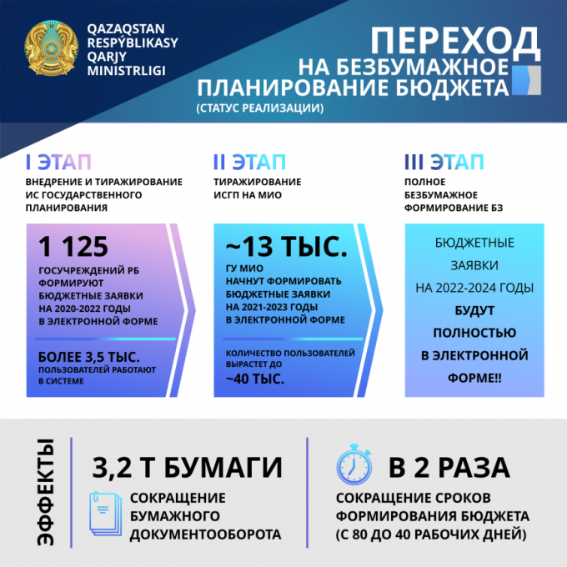
2. What will happen next?
At the next stage of development of the IS GP, it is proposed to automate all stages of the formation of budget applications by the ABP, taking into account the integration with state databases.
Implementation of the following functionality is proposed:
- automation of the process of obtaining information on forecasting budget revenues;
- on the payment of public debt and PPP projects;
- for goods from the EGZ in order to exclude the provision of 3 paper commercial offers from Suppliers;
- according to the staffing table of civil servants from IS e-Kyzmet;
- in the need for the payment of pensions and benefits from the IS MLSPP;
- budget investment projects, namely electronic passports of feasibility study and FEO from PPP JSC;
- in terms of obtaining an electronic passport for design and estimate documentation.
- for public discussion of expenses with the public, etc.
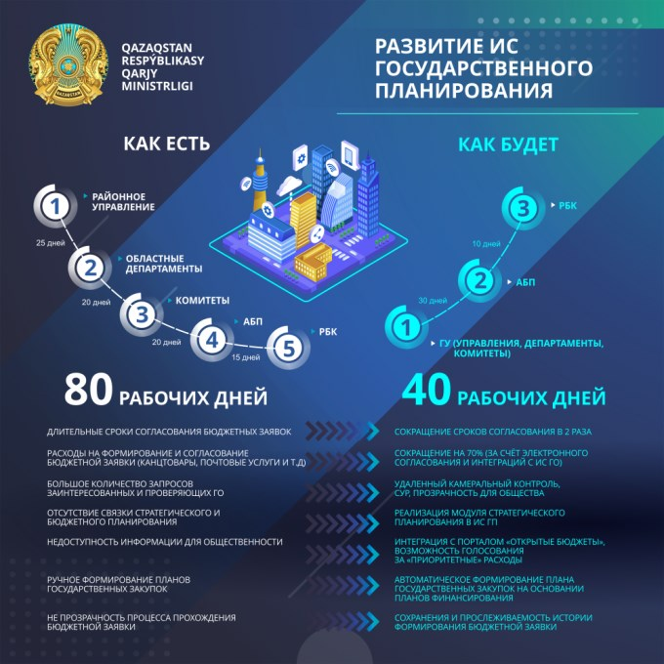
3. Integration with the "Open Budgets" portal
To improve the situation, the Ministry of Finance, in addition to legislative amendments, plans to integrate information systems with the Open Budgets portal.
Citizens will be able to view budget figures in the form of infographics and leave comments and vote on the initiative.
For government agencies, the Portal will be a single window for both strategic and budgetary planning of public funds, with the possibility of participation of regulatory bodies in it. So, in the future, there will be no need to print, manually initialize, and carry piles of documents.
4. Expected effects
- reduction of the terms of budget formation by 2 times.
- Improving planning accuracy through integrations with the Public Procurement Portal.
- ensuring transparent budget consolidation.
- ensuring transparency in the calculation of budget expenditures, which will increase public confidence in the government as a whole.
Automation of all budget planning processes will also bring huge economic benefits. Let's consider the integration of the budget planning system with the IS "Gosexpertiza" in terms of obtaining an electronic passport for design and estimate documentation.
Design and estimate documentation is a multivolume financial and technical document, the development of which requires significant budgetary funds. Approved with seals and signatures, the document is re-scanned and attached to the budget request.
This affects the efficiency of consideration and approval by the authorized body, and facts of falsification are not excluded.
Due to the fact that RSE "Gosexpertiza" in the past lost its monopoly, the market has already generated 25 thousand design estimates. In the IS "Gosexpertiza" itself, about 11 thousand projects of design and estimate documentation have been formed.
Integration of the budget planning system with the IS "Gosexpertiza" in terms of obtaining an Electronic passport design and estimate documentation, due to restrictions on the purchase cost of building materials, will reduce the cost of state construction in the IS.

